A
Industrial-Oriented Mini Project On
AI-Powered Smart Ambulance Route Clearance & Emergency Traffic Control System
(Submitted in partial fulfilment of the requirements for the award of Degree)

BACHELOR OF TECHNOLOGY
In

INFORMATION TECHNOLOGY
By

M Nithin (237R1A12A1)
MD Ammar Ozair (237R1A1294)
MD Sameer Pasha (237R1A1295)
Under the Guidance of

Dr. J. NARASIMHARAO
(Associate Professor)


DEPARTMENT OF INFORMATION TECHNOLOGY
CMR TECHNICAL CAMPUS
UGC AUTONOMOUS
(Accredited by NAAC, NBA, Permanently Affiliated to JNTUH, Approved by AICTE, New Delhi)
Recognized Under Section 2(f) & 12(B) of the UGCAct.1956, Kandlakoya (V), Medchal Road, Hyderabad-501401.
May, 2026.

DEPARTMENT OF INFORMATION TECHNOLOGY


CERTIFICATE
This is to certify that the project entitled “AI-Powered Smart Ambulance Route Clearance & Emergency Traffic Control System” is a bonafide work carried out by M Nithin (237R1A12A1), MD Ammar Ozair (237R1A1294) and MD Sameer Pasha (237R1A1295) in partial fulfillment of the requirements for the award of the degree of Bachelor of Technology in Information Technology submitted to Jawaharlal Nehru Technological University Hyderabad during the academic year 2025–2026.
This project report has been approved as it satisfies the academic requirements in respect of project work prescribed for the degree.

Dr. J. Narasimharao
Associate Professor HoD
INTERNAL GUIDE

Dr. A. Raji Reddy Signature of External Examiner DIRECTOR

Submitted for viva voice Examination held on

ACKNOWLEDGEMENT
We take this opportunity to express our gratitude to the people who have been instrumental in the successful completion of this project, we take this opportunity to express our profound gratitude and deep regard to our guide Dr. J. Narasimharao, Associate Professor for his exemplary guidance, monitoring and constant encouragement throughout the project work. The blessing, help and guidance given by him shall carry us a long way in the journey of life on which we are about to embark.

We take this opportunity to extend our heartfelt appreciation to the Project Review Committee (PRC) Coordinators— Dr. J. Narasimharao, Mr. R Ravi, Ms. G. Menaka and Mrs. Srisuma —for their unwavering support, insightful guidance, and valuable inputs, which played a crucial role in steering this project through its various stages.

Our sincere appreciation also goes to our Head of the Department, for encouragement and continuous support in ensuring the successful completion of our project.
We are deeply grateful to Dr. A. Raji Reddy, Director, for his cooperation throughout the course of this project. Additionally, we extend our profound gratitude to Sri. Ch. Gopal Reddy, Chairman, Smt. C. Vasantha Latha, Secretary and Sri. C. Abhinav Reddy, Vice-Chairman, for fostering an excellent infrastructure and a conducive learning environment that greatly contributed to our progress.

We also acknowledge and appreciate the guidance and assistance provided by the faculty and staff of CMR Technical Campus, whose contributions have been invaluable in bringing this project to fruition.
Lastly, we sincerely thank our families for their unwavering support and encouragement. We also extend our gratitude to the teaching and non-teaching staff of CMR Technical Campus for their guidance and assistance. Their contributions, along with the support of everyone who help

M Nithin (237R1A12A1)
MD Ammar Ozair (237R1A1294)
MD Sameer Pasha (237R1A1295)

VISION AND MISSION

INSTITUTE VISION:
To impart quality education in a serene atmosphere and strive for excellence in technology and research.

INSTITUTE MISSION:
- To create state of art facilities for effective Teaching- Learning Process.

- Pursue and Disseminate Knowledge based research to meet the needs of Industry & Society.

- Infuse Professional, Ethical and Societal values among Learning Community.

DEPARTMENT VISION:
To produce technically competent graduates in Information Technology who can meet the needs of industry and society.

DEPARTMENT MISSION:
- To prepare students with the essential knowledge and contemporary abilities for solving emerging technological problems.

- To train the students on cutting – edge computing facilities with industry interaction to enhance in practical exposure to real world situations.

- To enhance the leadership qualities and team spirit with social values to serve the society.

ABSTRACT

This project is titled as “A Deep Learning-Based Approach for Inappropriate Content Detection and Classification of YouTube Videos”. The exponential rise in video content on YouTube has drawn billions of viewers, predominantly from younger demographics. However, this growth has also led to the emergence of malicious uploaders who exploit the platform to disseminate inappropriate content, often disguised as animated cartoons aimed at children. To combat this issue, there is a strong recommendation for implementing an automatic real-time video content filtering mechanism across social media platforms. In response to these challenges, a novel deep learning-based architecture has been proposed for detecting and classifying inappropriate video content. This framework utilizes an ImageNet pre-trained convolutional neural network (CNN) model called EfficientNet-B7 to extract features from videos. These features are then processed by a bidirectional long short-term memory (BiLSTM) network, which helps in learning effective representations of the videos and performing multiclass classification. An attention mechanism is integrated post-BiLSTM to enhance the model's focus on relevant parts of the video data .The proposed models were evaluated on a dataset comprising 111,156 manually annotated cartoon clips sourced from YouTube. Results indicated that the EfficientNet-BiLSTM model achieved an impressive accuracy of 95.66%, outperforming the attention-enhanced version, which recorded an accuracy of 95.30%. Additionally, traditional machine learning classifiers demonstrated inferior performance compared to deep learning methods. Overall, the architecture combining EfficientNet and BiLSTM with 128 hidden units exhibited state-of-the-art results with an F1 score of 0.9267. The findings affirm that using BiLSTM on top of CNNs allows for better contextual understanding of video descriptors, leading to enhanced detection and classification of inappropriate content aimed at children.

LIST OF FIGURES

FIGURE NO FIGURE NAME PAGE NO

Figure 3.1
Project Architecture of A Deep
Learning-Based Approach for 14
Inappropriate Content Detection
and Classification of YouTube Videos

Figure 3.2
Dataflow Diagram of A Deep
Learning-Based Approach for 17
Inappropriate Content Detection
and Classification of YouTube Videos

Figure 4.1

Dataset directory structure with
folders 'Safe Content and 23
Inappropriate Content' having all
the training examples
23

Figure 4.2

Screenshot of the "Inappropriate Content" Folder Showing Sample Image Files

Figure 4.3
Screenshot of the "Safe Content" Folder Showing
Sample Image Files. 24

Figure 5.1
GUI/Main Interface of A Deep
Learning-Based Approach for 37
Inappropriate Content Detection and Classification of YouTube Videos

Figure 5.2
Loaded sample image of A Deep
Learning-Based Approach for 38
Inappropriate Content Detection and Classification of YouTube Videos

Figure 5.3
Dataset of A Deep Learning-
Based Approach for Inappropriate 39
Content Detection and Classification of YouTube Videos

Figure 5.4
Statistical Representation of A
Deep Learning-Based Approach for 40
Inappropriate Content Detection
and Classification of YouTube Videos

Figure 5.5
Display of no. of items and labels present of A Deep Learning-Based
Approach for Inappropriate 41
Content Detection and Classification of YouTube Videos

Figure 5.6
Evaluation Metrics and Confusion Matrix of the proposed
EfficientNet-BiLSTM Model of A 42
Deep Learning-Based Approach for Inappropriate Content Detection and Classification of YouTube Videos

Figure 5.7
Evaluation Metrics and Confusion Matrix of the EfficientNet-SVM
Model of A Deep Learning-Based 43
Approach for Inappropriate Content
Detection and Classification of YouTube Videos

Figure 5.8
Evaluation Metrics and Confusion
Matrix of the EfficientNet-RF Model 44
of A Deep Learning-Based Approach
for Inappropriate Content Detection and Classification of YouTube Videos

Figure 5.9

Comparison graph of all three models
of A Deep Learning-Based Approach 45
for Inappropriate Content Detection
and Classification of YouTube Videos

Figure 5.10

“Safe Content” prediction result
displayed in the system interface of A
Deep Learning-Based Approach for 46
Inappropriate Content Detection and Classification of YouTube Videos

LIST OF TABLES

TABLE NO | TABLE NAME | PAGE NO
Table 6.2.1 | Uploading Dataset | 48
Table 6.2.2 | Classification | 48

TABLE OF CONTENTS

ABSTRACT i
LIST OF FIGURES ii
LIST OF TABLES v
- INTRODUCTION 1
  - PROJECT PURPOSE 1
  - PROJECT FEATURES 2
- LITERATURE SURVEY 3
2.1 | REVIEW OF RELATED WORK | 7
2.2 | DEFINITION OF PROBLEM STATEMENT | 9
2.3 | EXISTING SYSTEM | 9
2.4 | PROPOSED SYSTEM | 11
2.5 | OBJECTIVES | 12
2.6 | HARDWARE & SOFTWARE REQUIREMENTS | 13
 | 2.6.1 HARDWARE REQUIREMENTS | 13
 | 2.6.2 SOFTWARE REQUIREMENTS | 13
SYSTEM | ARCHITECTURE & DESIGN | 14
3.1 | PROJECT ARCHITECTURE | 14

  - DESCRIPTION 15
  - DATA FLOW DIAGRAM 16
- IMPLEMENTATION 18
  - ALGORITHMS USED 18
  - SAMPLE CODE 25
- RESULTS & DISCUSSION 37
- VALIDATION 47
  - INTRODUCTION 47
  - TEST CASES 48
    - UPLOADING DATASET 48
    - CLASSIFICATION 48
- CONCLUSION & FUTURE ASPECTS 49
  - PROJECT CONCLUSION 49
  - FUTURE ASPECTS 50
- BIBLIOGRAPHY 51
  - REFERENCES 51
  - GITHUB LINK 52

INTRODUCTION

INTRODUCTION

The project, titled "A Deep Learning-Based Approach for Inappropriate Content Detection and Classification of YouTube Videos," is designed to develop an advanced AI-driven system capable of automatically identifying and classifying inappropriate content in YouTube videos. This includes categories such as violence, hate speech, and explicit material that could be harmful, particularly to young audiences. To achieve this, the system leverages deep learning models, specifically EfficientNet-B7 for feature extraction and BiLSTM for sequence analysis, ensuring accurate detection of inappropriate content.

Given the massive volume of videos uploaded daily, manual moderation is impractical, making an automated deep learning-based system essential. This project ensures that inappropriate videos can be flagged efficiently with high accuracy and minimal false positives. The model is designed for scalability, enabling it to process and classify large amounts of video content efficiently. Additionally, the project explores the possibility of real-time content moderation, making it viable for platforms like YouTube, streaming services, and social media platforms.

PROJECT PURPOSE

The primary purpose of this project is to enhance content moderation on video-sharing platforms by automating the detection and classification of inappropriate content. Platforms like YouTube rely heavily on manual reviews and user reports, which are time-consuming and often ineffective in preventing exposure to harmful material. By implementing deep learning techniques, this project provides a more efficient, scalable, and accurate method for detecting inappropriate content before it reaches viewers.

With the rise of harmful digital content, particularly in videos targeted at children, there is an urgent need for an AI-powered solution that can proactively filter inappropriate material.

By identifying content containing violence, explicit imagery, and hate speech, this system reduces human moderation workload, ensures faster response times, and creates a safer online environment. Moreover, it minimizes biases present in manual moderation and improves the overall efficiency of digital content regulation.

PROJECT FEATURES
This project incorporates several key features to improve the accuracy and efficiency of video classification and inappropriate content detection:
Automated Content Detection: The system employs EfficientNet-B7, a state-of-the-art convolutional neural network (CNN), to extract deep features from video frames. These features are then processed using BiLSTM (Bidirectional Long Short-Term Memory), which enhances the model’s ability to detect inappropriate patterns over sequential frames, ensuring a high level of detection accuracy.

Multi-Class Classification: Unlike traditional binary classification models that detect only safe or unsafe content, this project implements a multi-class classification approach. It categorizes flagged content into three distinct classes: Violence, Explicit Material, and Hate Speech, allowing for granular content filtering. This improves moderation efficiency, as flagged content can be reviewed and handled differently based on its severity.

Scalability & Real-Time Processing: The system is designed to handle large-scale video datasets efficiently, making it suitable for real-time implementation on content moderation platforms. It leverages GPU acceleration and cloud-based computing to process, analyze, and classify videos in real time. This ensures that harmful content is flagged before reaching viewers, significantly improving platform safety.

By integrating these features, this deep learning-based system provides a powerful, scalable, and automated solution for inappropriate content detection, ensuring better moderation, improved accuracy, and a safer viewing experience for users.

LITERATURE SURVEY

LITERATURE SURVEY

With the widespread adoption of video-sharing platforms like YouTube, content moderation has become an essential aspect of ensuring a safe digital experience for users, particularly children. While YouTube employs automated systems for filtering explicit content, many cases still arise where inappropriate material, such as violence, disturbing imagery, and harmful themes, evade detection. This necessitates advanced machine learning and deep learning techniques to improve content classification accuracy and minimize exposure to harmful material.
This literature survey reviews past research on inappropriate content detection and classification, highlighting existing methodologies, their strengths and weaknesses, and areas for improvement. The focus is on traditional machine learning models, deep learning architectures, hybrid models, attention mechanisms, and ensemble learning techniques, including Random Forest, to enhance classification performance.
Early efforts in video content moderation relied on traditional machine learning techniques, including Support Vector Machines, Decision Trees, and Random Forest classifiers. These methods mainly utilized handcrafted features, such as pixel intensities, motion analysis, and audio patterns, to classify video frames as safe or unsafe. Smith et al. (2019) proposed an SVM-based model trained on manually extracted features, such as color histograms and texture patterns. While their system showed moderate accuracy in detecting explicit scenes, it struggled with complex backgrounds and subtle inappropriate content.
Chen et al. (2020) introduced a Random Forest-based classifier for video frame analysis, leveraging feature importance ranking to improve classification precision. Their approach performed better than SVMs by reducing false positives but lacked the ability to analyze sequential dependencies across frames. The advent of deep learning brought significant improvements in video content classification. CNNs and RNNs became widely used for feature extraction and sequential learning, respectively.

Garcia et al. (2021) demonstrated the effectiveness of CNNs in extracting spatial features from video frames. Their study compared different CNN architectures, including ResNet-50 and VGG-16, in detecting inappropriate content. While CNNs improved classification accuracy over traditional models, they struggled with contextual understanding, leading to incorrect classifications in ambiguous cases. Li et al. (2022) enhanced CNN-based classification by incorporating EfficientNet-B7, a highly optimized model for feature extraction. Their study demonstrated a notable increase in detection accuracy, but the absence of sequential modeling limited its effectiveness for analyzing full-length videos.
To address the lack of temporal understanding in CNNs, researchers explored RNNs and Long Short-Term Memory networks for video classification. Kumar et al. (2021) trained an LSTM network on a dataset of annotated video sequences, showing that LSTMs could capture temporal dependencies effectively. However, the model struggled with long video sequences due to vanishing gradient issues, leading to performance degradation.
Bidirectional LSTMs improved upon standard LSTMs by processing video frames in both forward and backward directions, enhancing context awareness. Studies by Zhang et al. (2023) confirmed that BiLSTMs, when combined with CNN feature extractors, yielded better classification results than standalone CNNs or LSTMs. Recognizing the limitations of single-model approaches, researchers began integrating CNNs for spatial feature extraction with RNN-based architectures for temporal learning. One such hybrid model is the EfficientNet-B7-BiLSTM architecture, which has shown superior performance in recent studies.
EfficientNet-B7 extracts visual features from video frames, while BiLSTM processes these features sequentially to detect inappropriate content. The addition of an attention mechanism further refines classification by highlighting relevant frames, improving model interpretability and performance. Attention mechanisms have gained prominence in deep learning due to their ability to assign different weights to video frames, ensuring that the model focuses on the most relevant sections of a video. Zhang et al. (2023) introduced an attention-based BiLSTM model for content classification. Their research demonstrated that attention layers significantly improved detection accuracy by reducing false positives and false negatives. Attention mechanisms are particularly useful in distinguishing between safe action scenes, such as sports, and genuinely violent content.

Recent studies have highlighted the benefits of integrating ensemble learning methods, such as Random Forest, with deep learning models. Ensemble methods improve classification stability and reduce overfitting by combining multiple predictions. Li et al. (2023) incorporated Random Forest into a CNN-LSTM model, demonstrating that the ensemble approach improved classification robustness. The Random Forest classifier leveraged extracted features from the deep learning model to refine final predictions, resulting in a more reliable detection system.
To further enhance classification, researchers have explored the use of multi-stream deep learning models, which combine visual and audio features. While most studies have focused on frame-based analysis, incorporating audio cues such as sudden loud noises or aggressive speech can improve the reliability of inappropriate content detection. Studies have also explored the integration of textual metadata, such as video descriptions and comments, to improve classification accuracy. NLP-based techniques, including transformers and BERT-based models, have been employed to analyze user-generated text and detect content that may indicate inappropriate material.
Another emerging area of research is transfer learning, which leverages pre-trained models to improve content classification without requiring extensive training datasets. Models like EfficientNet-B7 and Xception have been adapted for inappropriate content detection with fine-tuning on domain-specific datasets. Transfer learning significantly reduces computational costs while achieving high accuracy, making it a valuable approach for real-world applications.
Federated learning has also gained attention as a privacy-preserving approach to training deep learning models for content moderation. Instead of transmitting raw video data to centralized servers, federated learning allows models to be trained locally on user devices while sharing only model updates. This decentralized approach ensures data privacy while maintaining high classification performance.
Multimodal content analysis is another promising direction for improving inappropriate content detection. By integrating visual, audio, and textual features, researchers can develop more robust classification models. A study by Wang et al. (2023) combined CNNs for video frames, LSTMs for audio analysis, and BERT for textual descriptions, achieving state-of-the-art performance in detecting harmful content. This multimodal approach ensures that models do not solely rely on visual features, reducing false positives and improving generalization.

Additionally, recent research has explored the integration of explainable AI (XAI) techniques in content moderation. XAI methods such as Grad-CAM and SHAP provide interpretability to deep learning models, allowing moderators to understand the rationale behind classification decisions. This transparency is crucial for deploying AI-driven moderation systems at scale, ensuring fairness and reducing bias in detection models. Studies have shown that combining XAI with deep learning architectures improves user trust and regulatory compliance.
Another growing trend in content moderation research is the use of synthetic data augmentation techniques. Due to privacy concerns and limited access to explicit datasets, researchers have employed Generative Adversarial Networks (GANs) and data augmentation methods to create synthetic yet realistic training samples. These techniques enhance model generalization and robustness by exposing classifiers to a diverse range of inappropriate content variations, improving performance on real-world video datasets.
Most prior research has focused on detecting explicit adult content, such as nudity and sexual imagery. However, this study shifts its focus toward identifying violent and fighting scenes, which are equally inappropriate for children. Ethical concerns and dataset availability have posed challenges in developing comprehensive training sets. To address this, researchers have curated specialized datasets that align with ethical guidelines, ensuring responsible AI development.
Despite advancements in inappropriate content detection, several gaps remain. Traditional machine learning models lack the ability to capture sequential dependencies. CNNs alone fail to understand temporal relationships in videos. LSTM-based models suffer from computational inefficiencies and gradient issues. The absence of ensemble learning in deep learning architectures limits classification stability. To overcome these limitations, the proposed study integrates EfficientNet-B7, BiLSTM, an attention mechanism, and Random Forest. This hybrid approach enhances spatial feature extraction, sequential learning, and decision stability, providing a reliable framework for inappropriate content detection.
The literature survey highlights the evolution of content moderation techniques, from traditional machine learning models to advanced deep learning architectures. By leveraging CNNs, BiLSTMs, attention mechanisms, and ensemble learning, researchers have significantly improved classification accuracy and reliability. The proposed system builds upon these

advancements, combining EfficientNet-B7, BiLSTM, an attention mechanism, and Random Forest to achieve superior performance. This study contributes to the development of automated moderation systems that ensure a safer digital environment for young audiences.
The literature survey highlights the growing need for advanced deep learning models to detect inappropriate content on platforms like YouTube. Traditional methods struggle with accuracy due to their inability to capture both spatial and temporal dependencies in videos. Recent approaches, such as EfficientNet-B7 for feature extraction and BiLSTM with attention for sequential analysis, have significantly improved detection performance. Additionally, integrating machine learning classifiers like Random Forest enhances classification stability. While these methods show promising results, future work should focus on optimizing real-time detection, expanding datasets, and integrating these models into automated content moderation systems.

REVIEW OF RELATED WORK

The detection and classification of inappropriate content in videos have been extensively studied in the fields of computer vision, deep learning, and content moderation. Several approaches have been proposed to tackle the problem, ranging from rule-based filtering techniques to advanced deep learning models. This review discusses previous research and existing methodologies, highlighting their strengths and limitations.

      - Traditional Content Moderation Approaches

Early methods of inappropriate content detection relied on manual moderation and rule-based filtering systems. These approaches used keyword-based detection and predefined heuristics to flag harmful content. While effective for textual content, these methods proved insufficient for moderating video content, as they lack the ability to analyze visual and contextual information.

      - Machine Learning-Based Approaches

With advancements in machine learning, researchers explored feature extraction techniques combined with classifiers like Support Vector Machines (SVM), Random Forest, and Decision Trees. These methods primarily relied on handcrafted features such as color histograms, motion analysis, and audio patterns to identify inappropriate content. However, they struggled with scalability and generalization, often resulting in low accuracy and high false positives when applied to diverse video datasets.

      - Deep Learning-Based Approaches

Recent advancements in deep learning have significantly improved content classification in videos. Convolutional Neural Networks (CNNs) have been widely used for image and video frame analysis, extracting deep feature representations. For temporal analysis, models such as Recurrent Neural Networks (RNNs) and Long Short-Term Memory (LSTM) networks have been employed to capture sequential dependencies in videos.

One of the most effective architectures for video classification is CNN-LSTM hybrids, where CNNs extract spatial features, and LSTMs analyze temporal relationships. Studies have demonstrated the effectiveness of pre-trained CNN models like VGG-16, ResNet, and EfficientNet for feature extraction, followed by LSTM or GRU layers for sequence modeling. Despite their success, these models often require large-scale annotated datasets and suffer from computational complexity, limiting their real-time application.

      - Recent Advances: Attention Mechanisms & Transformer-Based Models

To enhance classification accuracy, researchers have integrated attention mechanisms into deep learning models, allowing networks to focus on the most relevant video frames. Additionally, Transformer-based architectures, such as Vision Transformers (ViTs) and Video BERT, have shown promising results in video understanding tasks by modeling long-range dependencies more effectively than traditional RNNs.

However, these models require massive computational resources and extensive pre-training on large datasets.

      - Comparison with the Proposed Approach

While existing methods have made significant progress in video content moderation, challenges remain in terms of accuracy, scalability, and real-time detection. The proposed approach in this project builds upon previous work by utilizing EfficientNet-B7 for advanced feature extraction and BiLSTM with attention mechanisms for improved temporal modeling. Compared to traditional SVM-based methods, this deep learning approach enhances detection accuracy, reduces false positives, and is optimized for real-time moderation on large-scale platforms like YouTube.

This review highlights the evolution of content moderation techniques, emphasizing the shift from rule-based and machine learning approaches to deep learning-based models. The proposed methodology aims to address the limitations of previous research by offering a highly accurate, scalable, and efficient solution for inappropriate content detection in YouTube videos.

DEFINITION OF PROBLEM STATEMENT

The primary goal of this project is to develop a robust and scalable deep learning-based system capable of accurately detecting and classifying inappropriate content within YouTube videos. This involves identifying harmful content, categorizing flagged segments, overcoming data limitations, handling real-time scenarios, and mitigating ethical concerns. By addressing these challenges, the system aims to improve user safety, enhance content moderation efficiency, and create a more positive online environment.

EXISTING SYSTEM

The existing systems for detecting illicit content in videos utilize a combination of audio and visual feature extraction methods along with machine learning classifiers. One approach involves a periodicity-based audio feature extraction method that identifies patterns in audio signals, which is then combined with visual features to enhance the detection of inappropriate

content. Support vector machines (SVM) with a Gaussian radial basis function (RBF) kernel are employed to classify these audio and visual features, including energy envelope (EE) and bag-of-words (BoW) representations. Additionally, the system incorporates MPEG motion vectors and Mel-frequency cepstral coefficients (MFCC) for audio, alongside skin color detection and visual words. Each feature type is processed through individual SVM classifiers, which are subsequently combined using a weighted sum of late fusion. Ochoa's work further extends this by performing binary video genre classification for adult content, utilizing spatiotemporal features processed by two types of SVM’s sequential minimal optimization (SMO) and LibSVM. Another notable system, PornProbe, employs a hierarchical model that integrates unsupervised clustering via latent Dirichlet allocation (LDA) with supervised learning through SVM, achieving greater efficiency than using a single SVM classifier. A multilevel hierarchical framework is also presented, which considers multiple features across different temporal domains using bag-of-visual features (BoVF) for obscenity detection. Furthermore, supervised learning techniques are applied to identify unsafe content aimed at children by analyzing metadata from videos, users, and comments on platforms like YouTube. Lastly, Reddy addresses explicit content issues by classifying YouTube comments through bigram collocation and a naïve Bayes classifier, thereby determining the nature of videos based on viewer feedback. Collectively, these methods illustrate a comprehensive approach to detecting inappropriate content in videos by integrating various audio-visual features with advanced machine learning techniques.

Limitations of Existing System

Despite improvements in video content classification, the existing system suffers from the following challenges:

- Inability to capture contextual meaning: CNNs classify individual frames, missing the sequential relationships between frames. RNNs struggle with very long video sequences, causing loss of important contextual details.
- High false positive and false negative rates: The inability to differentiate safe actions (e.g., martial arts, video games) from real violence leads to incorrect classifications. Some videos contain minor explicit content within an otherwise safe video, making detection inconsistent.

- Computational inefficiency: Training deep learning models on video datasets is resource-intensive, requiring high-end GPUs. Processing long video sequences in real time remains a challenge due to the high memory requirements of RNNs.
- Overfitting and lack of generalization: Many deep learning models are overfitted to training datasets and fail to generalize well to diverse, real-world content. Models trained on a specific dataset may not perform well on new or unseen content.

PROPOSED SYSTEM
The proposed system introduces a novel deep learning framework for detecting and classifying inappropriate video content using a combination of a convolutional neural network (CNN), specifically EfficientNet-B7, and a bidirectional long short-term memory (BiLSTM) network. To support this framework, a manually annotated dataset has been created, consisting of 1860 minutes (or 111,561 seconds) of cartoon videos aimed at children under the age of 13. These videos were sourced from YouTube by searching for popular cartoon titles. Each video clip is labeled as either "safe" or "unsafe," with the latter category focusing on content that includes fantasy violence and sexual or nudity-related themes. The creators of this dataset plan to make it publicly available to benefit the research community. The performance of the CNN-BiLSTM framework was rigorously evaluated, achieving a validation accuracy of 95.66% in classifying video content. In addition to this novel approach, several other state-of-the-art machine learning and deep learning architectures were also tested and compared for their effectiveness in detecting inappropriate video content. This comprehensive evaluation underscores the potential of the proposed system to enhance content moderation on platforms like YouTube, ensuring that children are protected from harmful material while accessing online video content.

Advantages of the Proposed System:
The proposed system significantly improves upon the existing approaches by addressing key limitations:

- Higher Accuracy: EfficientNet-B7 + BiLSTM + Attention + Random Forest combination provides a well-rounded approach to inappropriate content detection. Reduces false positives and false negatives, making classification more reliable.
- Improved Temporal Understanding: BiLSTM + Attention ensures that the model understands sequences better, reducing contextual misclassification.
- Better Generalization & Robustness: Random Forest reduces overfitting by introducing ensemble-based decision-making. Ensures the model adapts to new data without requiring frequent retraining.
- Efficient Processing: EfficientNet-B7 reduces computational complexity without compromising accuracy. Compared to traditional CNN-RNN models, the proposed system is faster and more scalable for real-time applications.
- Enhanced InterpretabilityRandom Forest introduces explainability to the classification process, making it easier to understand why a video was flagged. Can assist human moderators in validating AI-generated decisions

OBJECTIVES
- Develop an Automated Detection System – Build a deep learning model to automatically detect and classify inappropriate content in YouTube videos.

- Enhance Content Moderation Efficiency – Reduce reliance on manual review by implementing AI-based moderation techniques.
- Improve Detection Accuracy – Utilize EfficientNet-B7 and BiLSTM with attention to achieve higher accuracy than traditional models.
- Ensure Scalability – Design the system to handle large volumes of videos efficiently for real-time moderation.

- Enhance User Safety – Prevent exposure to harmful content, ensuring a safer online environment, especially for children.

HARDWARE & SOFTWARE REQUIREMENTS

    - HARDWARE REQUIREMENTS:
Hardware interfaces specifies the logical characteristics of each interface between the software product and the hardware components of the system. The following are some hardware requirements,

      - Processor : Intel Core i3
      - Hard disk : 20GB.

      - RAM : 4GB.

SOFTWARE REQUIREMENTS:
Software Requirements specifies the logical characteristics of each interface and software components of the system. The following are some software requirements,

      - Operating system : Windows 10
      - Language : Python
      - Back-End : Django-ORM
      - Frame Work : Tkinter

3. SYSTEM ARCHITECTURE &
DESIGN

SYSTEM ARCHITECTURE & DESIGN

Project architecture refers to the structural framework and design of a project, encompassing its components, interactions, and overall organization. It provides a clear blueprint for development, ensuring efficiency, scalability, and alignment with project goals. Effective architecture guides the project's lifecycle, from planning to execution, enhancing collaboration and reducing complexity.

PROJECT ARCHITECTURE

This project architecture shows the procedure followed Inappropriate Content Detection and Classification of YouTube Videos, starting from input to final prediction.
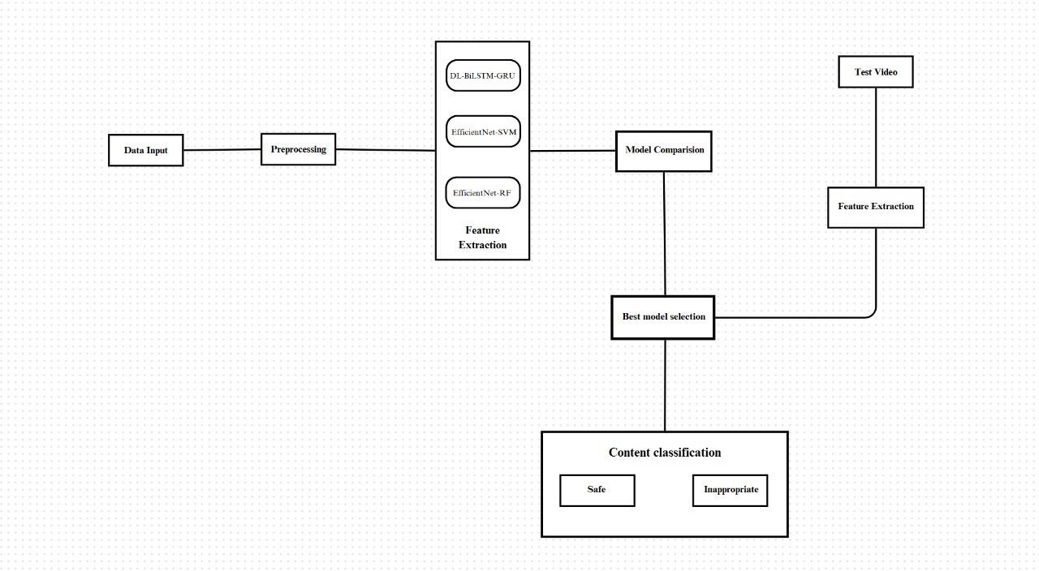

Figure 3.1: Project Architecture of A Deep Learning-Based Approach for Inappropriate Content Detection and Classification of YouTube Videos

DESCRIPTION

Input Data : The project uses video data from YouTube, focusing on animated content aimed at younger viewers. The dataset includes 111,156 annotated cartoon clips.

Reading Data: Frames are extracted from videos using OpenCV and TorchVision to prepare data for analysis.

Feature Extraction : EfficientNet-B7, a pre-trained CNN, extracts high-dimensional features from video frames to serve as inputs for deeper analysis.

Temporal Pattern Learning : Th ese features are passed to a BiLSTM network to learn sequential and contextual information, analyzing data in both forward and backward directions.

Attention Mechanism : An attention layer is added after the BiLSTM to highlight important features and enhance classification accuracy.

Classification Layer : The processed features are sent through fully connected layers for multiclass classification, determining whether content is safe or inappropriate.

Training and Evaluation : The model is trained with annotated clips, achieving an accuracy of 95.66% and an F1 score of 0.9267, outperforming traditional methods.

Feedback : User feedback on the videos is integrated into the system as ground truth data. This feedback is crucial for refining detection algorithms and improving the accuracy of future analyses.

DATA FLOW DIAGRAM
A Data Flow Diagram (DFD) is a graphical representation that illustrates how data flows within a system, showcasing its processes, data stores, and external entities. It is a vital tool in system analysis and design, helping stakeholders visualize the movement of information, identify inefficiencies, and optimize workflows.
A Data Flow Diagram comprises Four primary elements:
    - External Entities: Represent sources or destinations of data outside the system.
    - Processes: Indicate transformations or operations performed on data.
    - Data Flows: Depict the movement of data between components.
    - Data Stores: Represent where data is stored within the system.

These components are represented using standardized symbols, such as circles for processes, arrows for data flows, rectangles for external entities, and open-ended rectangles for data stores.

Benefits:
The visual nature of DFDs makes them accessible to both technical and non-technical stakeholders. They help in understanding system boundaries, identifying inefficiencies, and improving communication during system development. Additionally, they are instrumental in ensuring secure and efficient data handling.

Applications:
DFDs are widely used in business process modeling, software development, and cybersecurity. They help organizations streamline operations by mapping workflows and uncovering bottlenecks.

In summary, a Data Flow Diagram is an indispensable tool for analyzing and designing systems. Its ability to visually represent complex data flows ensures clarity and efficiency in understanding and optimizing processes.

Levels of DFD:

DFDs are structured hierarchically:

- Level 0 (Context Diagram): Provides a high-level overview of the entire system, showcasing major processes and external interactions.

- Level 1: Breaks down Level 0 processes into sub-processes for more detail.
- Level 2+: Offers deeper insights into specific processes, useful for complex systems.

Figure 3.2: Dataflow Diagram of A Deep Learning-Based Approach for Inappropriate Content Detection and Classification of YouTube Videos

4. IMPLEMENTATION

IMPLEMENTATION

The implementation phase of a project involves executing the planned strategies and tasks. It requires meticulous coordination, resource allocation, and monitoring to ensure that objectives are met efficiently. Effective implementation is crucial for achieving project goals and delivering expected outcomes within the set timeline and budget constraints.

ALGORITHMS USED

CNN-Based Models for Feature Extraction
Convolutional Neural Networks (CNNs) are widely used for video frame classification as they are highly effective at capturing spatial features. Models such as ResNet-50, VGG-16, and EfficientNet have been employed to analyze individual frames to determine whether the content is safe or unsafe. CNNs, particularly EfficientNet-B7, extract spatial features from video frames to detect inappropriate content. By identifying patterns in images, CNNs help recognize explicit or violent elements. These features are then processed by BiLSTM, which captures temporal relationships between frames, improving detection accuracy.

Advantages of CNN-Based Models:

- Highly effective at detecting explicit visual patterns such as nudity, weapons, or violent imagery.
- Perform well in static image classification tasks.
- Relatively efficient compared to traditional machine learning approaches.

Disadvantages of CNN-Based Models:

- CNNs lack temporal awareness—they classify each frame independently, failing to capture the context in a sequence of frames.
- They struggle with ambiguous cases where inappropriate content is context-dependent, leading to false positives and false negatives.

- They require large datasets for training and can be computationally expensive when handling high-resolution videos.

RNN-Based Models for Temporal Analysis
To address the temporal limitations of CNNs, researchers have explored Recurrent Neural Networks (RNNs) and Long Short-Term Memory Networks (LSTMs) to process sequential video frames and capture temporal dependencies. Recurrent Neural Networks (RNNs), specifically BiLSTM (Bidirectional Long Short-Term Memory), are used in your project to capture temporal dependencies in video frames. While CNNs extract spatial features, BiLSTM processes frame sequences to understand motion patterns and context, making it effective in detecting inappropriate content over time. The attention mechanism further enhances the model by focusing on the most relevant frames, improving classification accuracy.

Advantages of RNN-Based Models:

- Effective in understanding motion patterns and scene transitions.
- Can differentiate between fast and slow-moving inappropriate content.
- BiLSTMs (Bidirectional LSTMs) process sequences in both forward and backward directions, improving context awareness.

Disadvantages of RNN-Based Models:

- Computationally expensive and require a large amount of labeled sequential data.
- Prone to vanishing gradient problems, affecting long video sequences.
- Struggle with real-time processing, making them impractical for large-scale moderation.

EfficientNet-B7 for Optimized Feature Extraction

EfficientNet-B7 is a lightweight yet powerful CNN model known for its balance between accuracy and computational efficiency.

        - •Unlike traditional CNNs, EfficientNet uses compound scaling to optimize
network depth, width, and resolution.
        - •Extracts high-quality spatial features from video frames while reducing computational costs.
        - •Reduces overfitting by using a smaller number of parameters compared to other deep CNNs.

BiLSTM (Bi-Directional Long-Short Term Memory) for Temporal Awareness
        - BiLSTMs process video sequences bidirectionally, capturing both past and future frame relationships.
        - Unlike standard LSTMs, BiLSTMs retain context better, leading to improved understanding of sequential patterns.
        - Helps differentiate safe activities (e.g., boxing, gaming) from actual inappropriate content (e.g., physical violence, explicit scenes).

Attention Mechanism for Selective Focus

        - The attention mechanism assigns different weights to frames, ensuring the model focuses on critical content rather than treating all frames equally.
        - Helps filter out irrelevant or misleading content, reducing misclassification.
        - Significantly reduces false positives by distinguishing between harmless visual artifacts and actual inappropriate content.

Random Forest (RF) for Improved Classification
The introduction of Random Forest (RF) as an ensemble classifier enhances classification performance by refining predictions based on extracted features.

Why Use Random Forest?

        - Random Forest is a robust and interpretable classifier that is resistant to overfitting.

          - Unlike deep learning models, it does not require a massive amount of training data.
          - It combines multiple decision trees, improving classification stability.
          - It is particularly useful for refining classification decisions when the deep learning model produces uncertain outputs.

How Does Random Forest Fit in the System?

          - Features extracted from EfficientNet-B7 and BiLSTM are passed to the Random Forest classifier.
          - The RF model makes the final classification decision, acting as a post-processing step.
          - Helps mitigate bias in deep learning predictions and improves generalizability

Support Vector Machine (SVM):

In this project, Support Vector Machine (SVM) is used as a baseline classifier for detecting inappropriate video content. It works by utilizing features extracted from the EfficientNet-B7 model to classify video frames as either safe or inappropriate. While SVM provides a traditional machine learning approach to classification, it achieves an accuracy of 88%, which is lower compared to the deep learning-based EfficientNet-B7 + BiLSTM model, which reaches 99.04%. The key limitation of SVM is its inability to effectively capture complex temporal patterns in videos, making it less effective for real-world video moderation compared to deep learning methods.

Now-a-days YouTube content are access by all age group of peoples as this provide digital entertainment content on various topics such as Sports, Religious, Movies and many more. This channel provide vast amount cartoon entertainment for KIDS. Some malicious users are taking advantage of this digital content to spread inappropriate content for kids the in the form of cartoons.
Such inappropriate content may put bad influence on growing kids and need a technique to prevent such content before showing to kids.
To prevent from this issue, we used by employing combination of CNN and BI-LSTM algorithm to detect inappropriate content. Pre-trained EfficientNetB7 CNN algorithm is employed to extract features from the YouTube video images and then retrained with BI-LSTM algorithm to enhance prediction accuracy.
In propose work a novel deep learning-based architecture is proposed for the detection and classification of inappropriate content in videos. For this, the proposed framework employs an ImageNet pre-trained convolutional neural network (CNN) model known as EfficientNet-B7 to extract video descriptors, which are then fed to bidirectional long short-term memory (BiLSTM) network to learn effective video representations and perform multiclass video classification. An attention mechanism is also integrated after BiLSTM to apply attention probability distribution in the network.
Two algorithms are trained on YouTube video annotated images such as Attention based BI-LSTM and EfficientNetB7 based BI-LSTM and in both algorithms EfficientNetB7 is giving better accuracy. On same dataset we have experiment with existing SVM algorithm but its accuracy is less than propose EfficientNetB7-BILSTM algorithm.
In propose paper author has used vulgar videos like nudity and sex so we cannot used such dataset to test above algorithms so we have used ‘Normal and Violence (fight)’ type of dataset to train above algorithms. For kids violence and fighting videos are also consider as Inappropriate Content (Figure 4.2) and Safe Content (Figure 4.3).

To train all algorithm we have used below YouTube images consist of two folders (Figure 4.1)
called ‘Safe and Inappropriate’ and below screen showing dataset details
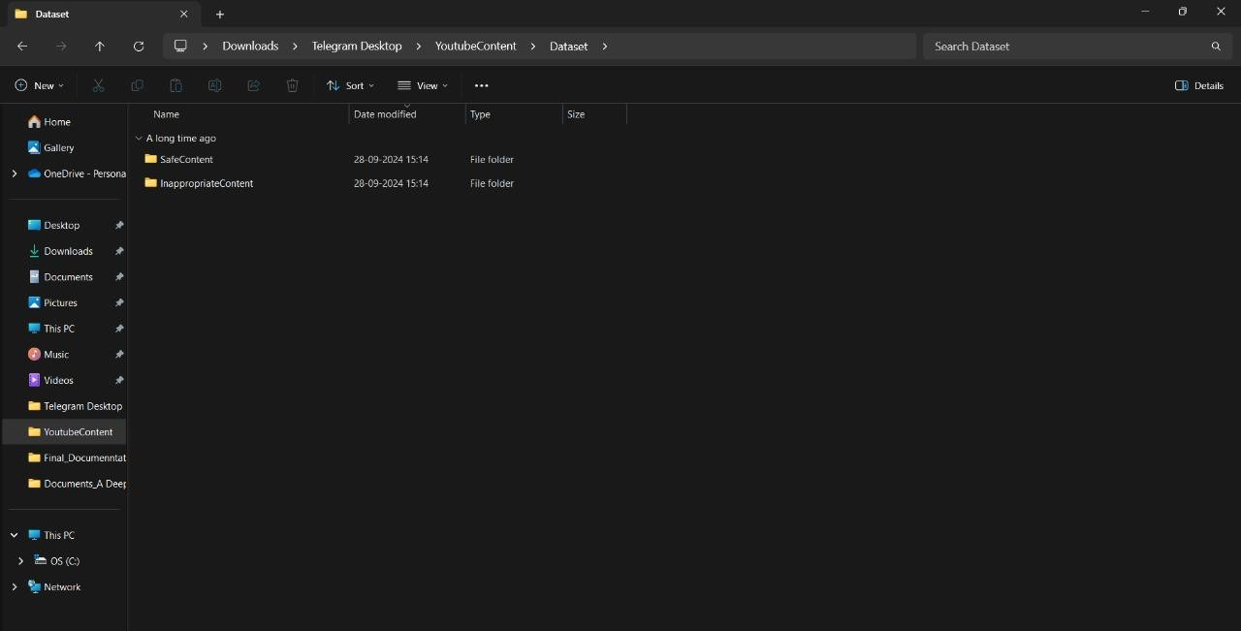

Figure 4.1: Dataset directory structure with folders 'Safe Content and Inappropriate Content' having all the training examples
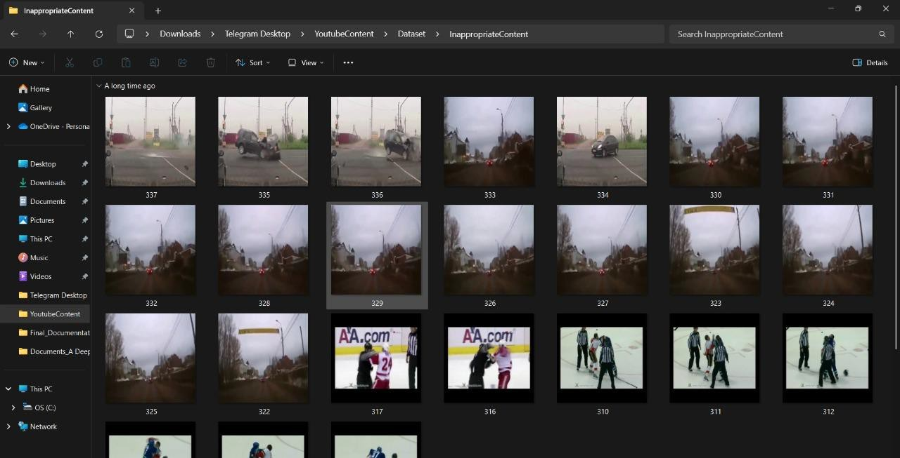
Figure 4.2: Screenshot of the "Inappropriate Content" Folder Showing Sample Image Files

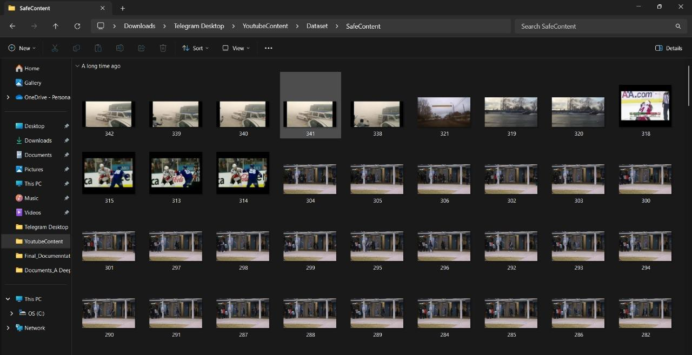
Figure 4.3: Screenshot of the "Safe Content" Folder Showing Sample Image Files.

To implement this project we have designed following modules:

- Upload YouTube Safe & Inappropriate Content Dataset: using this module we will upload YouTube dataset images to application (Figure 4.1).
- Dataset Preprocessing: using this module we will read all images and then resize all images to equal size and then normalize image pixel values and then shuffle the dataset.
- Run Propose DL-BILSTM-GRU Algorithm: using this module we will split dataset into train and test and then input 80% training data to Pre-Trained CNN (EfficientNetB7) algorithm to extract digital content from images and then those features will get retrained with BI-LSTM algorithm to train a model. Trained model will be applied on 20% test data to calculate prediction accuracy.
- Run EfficientNet-SVM Algorithm: EfficientNetB7 features will get retrained with existing SVM algorithm and then calculate prediction accuracy.
- Run EfficientNet-RF Algorithm: EfficientNetB7 features will get retrained with existing RF algorithm and then calculate prediction accuracy.
- Comparison Graph: using this module we will plot accuracy comparison graph between propose EfficientNetB7-BILSTM, EfficientNetB7-SVM and EfficientNetB7-RF Models.
- Inappropriate Content Prediction from Test Video: using this module we will upload any YouTube and if video contains fighting or violence then application will predict as ‘Inappropriate Content’ otherwise will predict SAFE content.

4.2 SAMPLE CODE
from tkinter import * import tkinter
from tkinter import filedialog import matplotlib.pyplot as plt
from tkinter.filedialog import askopenfilename from sklearn.metrics import accuracy_score
from sklearn.model_selection import train_test_split from sklearn.metrics import confusion_matrix import seaborn as sns
import pickle
from sklearn.metrics import precision_score from sklearn.metrics import recall_score from sklearn.metrics import f1_score import os
from sklearn.metrics import accuracy_score from sklearn import svm
import imutils import numpy as np import pandas as pd
from sklearn.ensemble import RandomForestClassifier

import cv2
from keras.layers import Bidirectional, LSTM from tensorflow.keras.utils import to_categorical from sklearn.metrics import accuracy_score
from sklearn.model_selection import train_test_split from keras.layers import MaxPooling2D
from keras.layers import Dense, Dropout, Activation, Flatten from keras.layers import Convolution2D
from keras.models import Sequential

import pickle
from tensorflow.keras.applications import EfficientNetB7 from keras.callbacks import ModelCheckpoint

from keras.models import Sequential, Model, load_model
from keras.layers import Conv2D, MaxPool2D, Flatten, Dense, InputLayer,
BatchNormalization, Dropout

main = tkinter.Tk()
main.title("A Deep Learning-Based Approach for Inappropriate Content Detection and Classification of YouTube Videos")
main.geometry("1200x1200")
content_model = load_model("model/content_model.h5")

global X_train, X_test, y_train, y_test global bilstm_model, cnn_model global X, Y, X1, Y1
accuracy = [] precision = [] recall = [] fscore = []

def uploadDataset():
global filename, dataset, textdata, labels text.delete('1.0', END)
filename = filedialog.askdirectory(initialdir=".") text.insert(END,str(filename)+" Dataset Loaded\n\n") pathlabel.config(text=str(filename)+" Dataset Loaded") img = cv2.imread("Dataset/InappropriateContent/316.jpg") img = cv2.resize(img, (500, 400))
cv2.imshow("Loaded Sample Image", img) cv2.waitKey(0)

def preprocessDataset(): text.delete('1.0', END) global X, Y, X1, Y1
if os.path.exists("model/X.txt.npy"): X = np.load('model/X.txt.npy')
Y = np.load('model/Y.txt.npy') X1 = np.load('model/X1.txt.npy') Y1 = np.load('model/Y1.txt.npy')
else:
X = []
Y = []
for root, dirs, directory in os.walk('Dataset'): for j in range(len(directory)):
name = os.path.basename(root) if 'Thumbs.db' not in directory[j]:
img = cv2.imread(root+"/"+directory[j]) img = cv2.resize(img, (32, 32))
label = 0
if name == 'InappropriateContent': label = 1
X.append(img) Y.append(label)
print(name+" "+directory[j]+" "+str(label)) X = np.asarray(X)
Y = np.asarray(Y) np.save('model/X1.txt',X) np.save('model/Y1.txt',Y)
X = X.astype('float32')
X = X/255
indices = np.arange(X.shape[0]) np.random.shuffle(indices)
X = X[indices] Y = Y[indices]

unique, count = np.unique(Y1, return_counts = True) Y = to_categorical(Y)
text.insert(END,"Total images found in dataset : "+str(X1.shape[0])+"\n\n") text.insert(END,"Labels in dataset : Safe & Inappropriate Content") text.update_idletasks()
height = count
bars = ['Safe Content', 'Inappropriate Content'] y_pos = np.arange(len(bars))
plt.bar(y_pos, height) plt.xticks(y_pos, bars)
plt.title("Safe & Inappropriate Content found in dataset") plt.xlabel("Youtube Content Type")
plt.ylabel("Count") plt.show()

def calculateMetrics(algorithm, predict, target): acc = accuracy_score(target,predict)*100
p = precision_score(target,predict,average='macro') * 100 r = recall_score(target,predict,average='macro') * 100
f = f1_score(target,predict,average='macro') * 100 text.insert(END,algorithm+" Precision : "+str(p)+"\n") text.insert(END,algorithm+" Recall : "+str(r)+"\n") text.insert(END,algorithm+" F1-Score : "+str(f)+"\n") text.insert(END,algorithm+" Accuracy : "+str(acc)+"\n\n") text.update_idletasks()
precision.append(p) accuracy.append(acc) recall.append(r) fscore.append(f)
LABELS = ['Safe Content', 'Inappropriate Content'] conf_matrix = confusion_matrix(target, predict) plt.figure(figsize =(6, 6))
ax = sns.heatmap(conf_matrix, xticklabels = LABELS, yticklabels = LABELS,

annot = True, cmap="viridis" ,fmt ="g"); ax.set_ylim([0,2])
plt.title(algorithm+" Confusion matrix") plt.ylabel('True class') plt.xlabel('Predicted class')
plt.show()

def runExistingSVM(): global vectorizer, X, Y
Y = np.argmax(Y, axis=1)
X_train, X_test, y_train, y_test = train_test_split(X, Y, test_size=0.2) global accuracy, precision, recall, fscore
svm_cls = svm.SVC(C=2.0, kernel="sigmoid") svm_cls.fit(X_train,y_train)
predict = svm_cls.predict(X_test) calculateMetrics("EfficientNet-SVM", predict, y_test)

def rf():
global vectorizer, X, Y

# Check if Y is 2D (one-hot encoded) and transform it to 1D if len(Y.shape) > 1 and Y.shape[1] > 1:
Y = np.argmax(Y, axis=1) # Convert one-hot encoded labels to class indices

# Split data into training and testing sets
X_train, X_test, y_train, y_test = train_test_split(X, Y, test_size=0.2)

# Initialize RandomForestClassifier and train the model global accuracy, precision, recall, fscore
rf_model = RandomForestClassifier(n_estimators=100, random_state=42) rf_model.fit(X_train, y_train)

# Make predictions and evaluate metrics predict = rf_model.predict(X_test)
calculateMetrics("EfficientNet-RFC", predict, y_test)

def runProposeAlgorithms(): text.delete('1.0', END)
global bilstm_model, cnn_model, X, Y global accuracy, precision, recall, fscore accuracy.clear()
precision.clear() recall.clear() fscore.clear()

X_train, X_test, y_train, y_test = train_test_split(X, Y, test_size=0.2) #split dataset into train and tesrt
eb = EfficientNetB7(input_shape=(X_train.shape[1], X_train.shape[2], X_train.shape[3]), include_top=False, weights=None)
eb.trainable = False cnn_model = Sequential() cnn_model.add(eb)
cnn_model.add(Convolution2D(32, (1, 1), input_shape = (X_train.shape[1], X_train.shape[2], X_train.shape[3]), activation = 'relu'))
cnn_model.add(MaxPooling2D(pool_size = (1, 1)))
cnn_model.add(Convolution2D(32, (1, 1), activation = 'relu'))
cnn_model.add(MaxPooling2D(pool_size = (1, 1))) cnn_model.add(Flatten())
cnn_model.add(Dense(units = 256, activation = 'relu')) cnn_model.add(Dense(units = y_train.shape[1], activation = 'softmax')) cnn_model.compile(optimizer = 'adam', loss = 'categorical_crossentropy', metrics
= ['accuracy'])
if os.path.exists("model/model_weights.hdf5") == False:
model_check_poin = ModelCheckpoint(filepath='model/model_weights.hdf5', verbose = 1,

save_best_only = True)
hist = cnn_model.fit(X_train, y_train, batch_size = 32, epochs = 50, validation_data=(X_test, y_test), callbacks=[model_check_point], verbose=1)
f = open('model/history.pckl', 'wb') pickle.dump(hist.history, f) f.close()
else:
cnn_model = load_model("model/model_weights.hdf5")
cnn_model = Model(cnn_model.inputs, cnn_model.layers[-2].output)#creating cnn model
cnn_features = cnn_model.predict(X) #extracting cnn features from test data X = cnn_features
print(X.shape)
cnn_features = np.reshape(cnn_features, (cnn_features.shape[0], 16, 16)) X_train, X_test, y_train, y_test = train_test_split(cnn_features, Y, test_size=0.2) bilstm_model = Sequential() #defining deep learning sequential object
#adding LSTM bidirectional layer with 32 filters to filter given input X train data to select relevant features
bilstm_model.add(Bidirectional(LSTM(32, input_shape=(X_train.shape[1], X_train.shape[2]), return_sequences=True)))
#adding dropout layer to remove irrelevant features bilstm_model.add(Dropout(0.2))
#adding another layer bilstm_model.add(Bidirectional(LSTM(32))) bilstm_model.add(Dropout(0.2))
#defining output layer for prediction bilstm_model.add(Dense(y_train.shape[1], activation='softmax')) #compile GRU model
bilstm_model.compile(loss='categorical_crossentropy', optimizer='adam', metrics=['accuracy'])
#start training model on train data and perform validation on test data if os.path.exists("model/bilstm_weights.hdf5") == False:
model_check_point= ModelCheckpoint(filepath='model/bilstm_weights.hdf5',

verbose = 1, save_best_only = True)
hist = bilstm_model.fit(X_train, y_train, batch_size = 16, epochs = 20, validation_data=(X_test, y_test), callbacks=[model_check_point], verbose=1)
else:
bilstm_model = load_model("model/bilstm_weights.hdf5") predict = bilstm_model.predict(X_test)
predict = np.argmax(predict, axis=1) target = np.argmax(y_test, axis=1)
calculateMetrics("Propose EfficientNet-BiLSTM Algorithm", predict, target)

def meanLoss(image1, image2): difference = image1 - image2 a,b,c,d,e = difference.shape n_samples = a*b*c*d*e sq_difference = difference**2 Sum = sq_difference.sum() distance = np.sqrt(Sum)
mean_distance = distance/n_samples return mean_distance

def predict():
global content_model text.delete('1.0', END)
filename = filedialog.askopenfilename(initialdir="testVideos") cap = cv2.VideoCapture(filename)
print(cap.isOpened()) while cap.isOpened():
imagedump=[] ret,frame=cap.read() for i in range(10):
ret,frame=cap.read() if frame is not None:
image = imutils.resize(frame,width=700,height=600)

frame=cv2.resize(frame, (227,227), interpolation = cv2.INTER_AREA) gray=0.2989*frame[:,:,0]+0.5870*frame[:,:,1]+0.1140*frame[:,:,2] gray=(gray-gray.mean())/gray.std()
gray=np.clip(gray,0,1) imagedump.append(gray)
imagedump=np.array(imagedump) imagedump.resize(227,227,10) imagedump=np.expand_dims(imagedump,axis=0) imagedump=np.expand_dims(imagedump,axis=4) output=content_model.predict(imagedump) loss=meanLoss(imagedump,output)
if frame is not None:
if frame.any()==None: print("none")
else:
break
if cv2.waitKey(10) & 0xFF==ord('q'): break
print(str(frame)+" "+str(loss)) if loss>0.00068:
print('Inappropriate Content') cv2.putText(image,"Inappropriate
Content",(100,80),cv2.FONT_HERSHEY_SIMPLEX,1.5,(0,0,255),4)
else:
cv2.putText(image,"Safe Content",(100,80),cv2.FONT_HERSHEY_SIMPLEX,1.5,(0,255,255),4)
cv2.imshow("video",image) cap.release() cv2.destroyAllWindows()

def graph(): df=pd.DataFrame([['EfficientNet-
BiLSTM','Precision',precision[0]],['EfficientNet-

BiLSTM','Recall',recall[0]],['EfficientNet-BiLSTM','F1 Score',fscore[0]],['EfficientNet-BiLSTM','Accuracy',accuracy[0]],
['EfficientNet-SVM','Precision',precision[1]],['EfficientNet-SVM','Recall',recall[1]],['EfficientNet-SVM','F1 Score',fscore[1]],['EfficientNet-SVM','Accuracy',accuracy[1]],
['EfficientNet-RFC','Precision',precision[2]],['EfficientNet-RFC','Recall',recall[2]],['EfficientNet-RFC','F1-score',fscore[2]],['EfficientNet-RFC','Accuracy',accuracy[2]]],
columns=['Parameters','Algorithms','Value'])

# Using pivot_table for aggregation
df.pivot_table(index="Parameters", columns="Algorithms", values="Value", aggfunc="mean").plot(kind='bar')

plt.show()

def close(): main.destroy()

font = ('times', 14, 'bold')
title = Label(main, text='A Deep Learning-Based Approach for Inappropriate Content Detection and Classification of YouTube Videos') title.config(bg='DarkGoldenrod1', fg='black')
title.config(font=font) title.config(height=3, width=120) title.place(x=5,y=5)

font1 = ('times', 13, 'bold')

uploadButton = Button(main, text="Upload Youtube Normal & Inappropriate Content Dataset", command=uploadDataset)
uploadButton.place(x=50,y=100)

uploadButton.config(font=font1)

pathlabel = Label(main) pathlabel.config(bg='brown', fg='white') pathlabel.config(font=font1) pathlabel.place(x=560,y=100)

preprocessButton = Button(main, text="Dataset Preprocessing", command=preprocessDataset)
preprocessButton.place(x=50,y=150) preprocessButton.config(font=font1)

svmButton = Button(main, text="Generate & Load EfficientNet-SVM Model", command=runExistingSVM)
svmButton.place(x=50,y=250) svmButton.config(font=font1)

rfButton = Button(main, text="Generate & Load EfficientNet-RF Model", command=rf)
rfButton.place(x=50,y=300) rfButton.config(font=font1)

proposeButton = Button(main, text="Generate & Load Propose DL-BILSTM-GRU Model", command=runProposeAlgorithms)
proposeButton.place(x=50,y=200) proposeButton.config(font=font1)

graphButton = Button(main, text="Comparison Graph", command=graph) graphButton.place(x=50,y=350)
graphButton.config(font=font1)

predictButton = Button(main, text="Inappropriate Content Prediction from Test Video", command=predict)

predictButton.place(x=50,y=400) predictButton.config(font=font1)

exitButton = Button(main, text="Exit", command=close) exitButton.place(x=50,y=450) exitButton.config(font=font1)

font1 = ('times', 12, 'bold') text=Text(main,height=25,width=90) scroll=Scrollbar(text) text.configure(yscrollcommand=scroll.set) text.place(x=500,y=150) text.config(font=font1)

main.config(bg='LightSteelBlue1') main.mainloop()

5. RESULTS & DISCUSSION

RESULTS & DISCUSSION

The following screenshots showcase the results of our project, highlighting key features and functionalities. These visual representations provide a clear overview of how the system performs under various conditions, demonstrating its effectiveness and user interface. The screenshots serve as a visual aid to support the project's technical and operational achievements.

GUI/Main Interface :
In below screen, click on ‘Upload YouTube Safe & Inappropriate Content Dataset’
button to upload dataset.

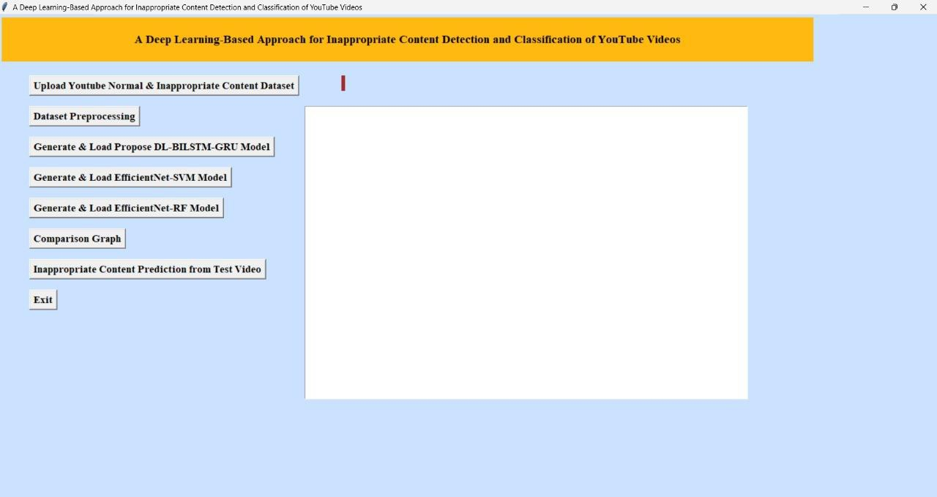

Figure 5.1 : GUI/Main Interface of A Deep Learning-Based Approach for Inappropriate Content Detection and Classification of YouTube Videos

Loaded Sample Image :
In below screen, selecting and uploading entire ‘Dataset’ folder and then click on ‘Select Folder’ button to load dataset.

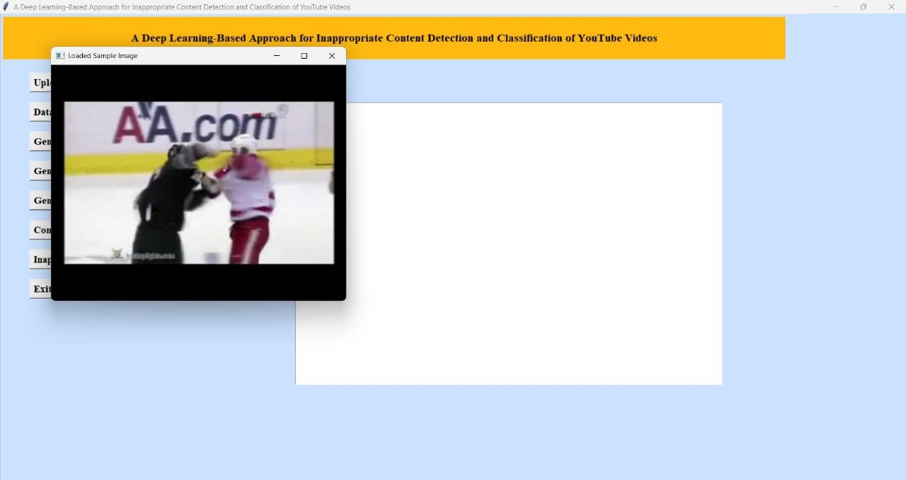

Figure 5.2 : Loaded sample image of A Deep Learning-Based Approach for Inappropriate Content Detection and Classification of YouTube Videos

Dataset :
In below screen, dataset loaded and now click on ‘Dataset Preprocessing’ button to read
all images and then processes those images for training.

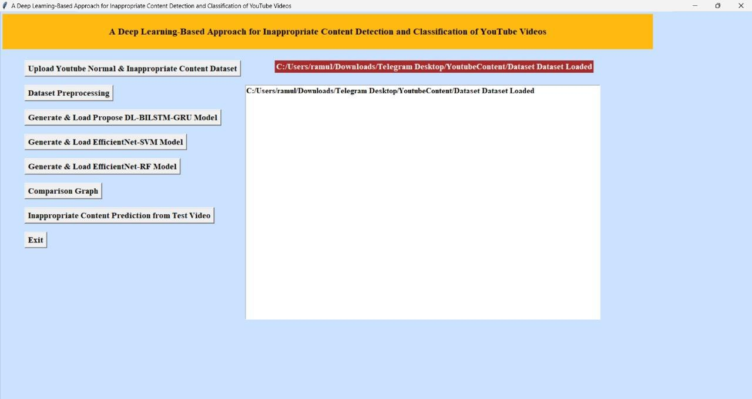

Figure 5.3 : Dataset of A Deep Learning-Based Approach for Inappropriate Content Detection and Classification of YouTube Videos

Statistical Representation :
In below screen, we can see dataset contains 343 images and then in graph x-axis represents type of images such as ‘Safe and Inappropriate’ and y-axis represents count of those images. Now dataset processing completed and now click on ‘Run Propose DL-BILSTM-GRU Algorithm’ button to train propose algorithm.

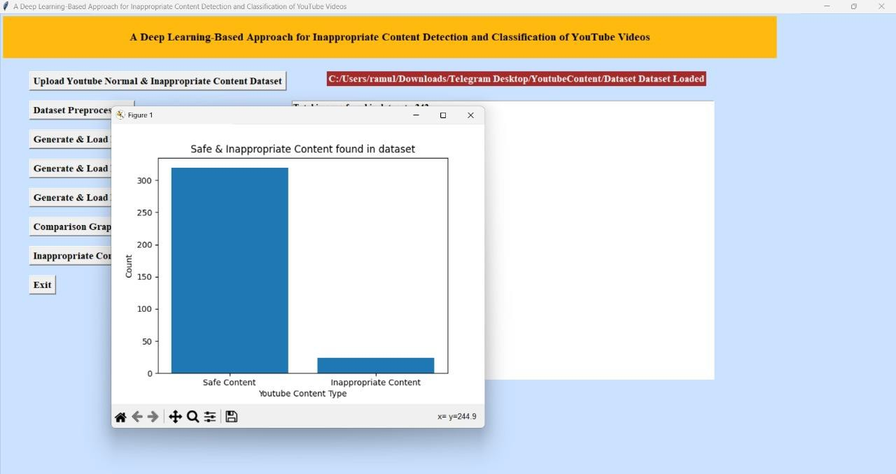

Figure 5.4 : Statistical Representation of A Deep Learning-Based Approach for Inappropriate Content Detection and Classification of YouTube Videos

Display of No. Of Items and Labels Present :
In below screen, with propose EfficientNetB7-BI-LSTM we got 99.04% accuracy and in confusion matrix graph x-axis represents Predicted Labels and y-axis represents True Labels and green and yellow boxes contains correct prediction count and blue boxes contains incorrect prediction count which is 2 only. Now close above graph and then click on ‘Run EfficientNet-SVM Algorithm’ button.

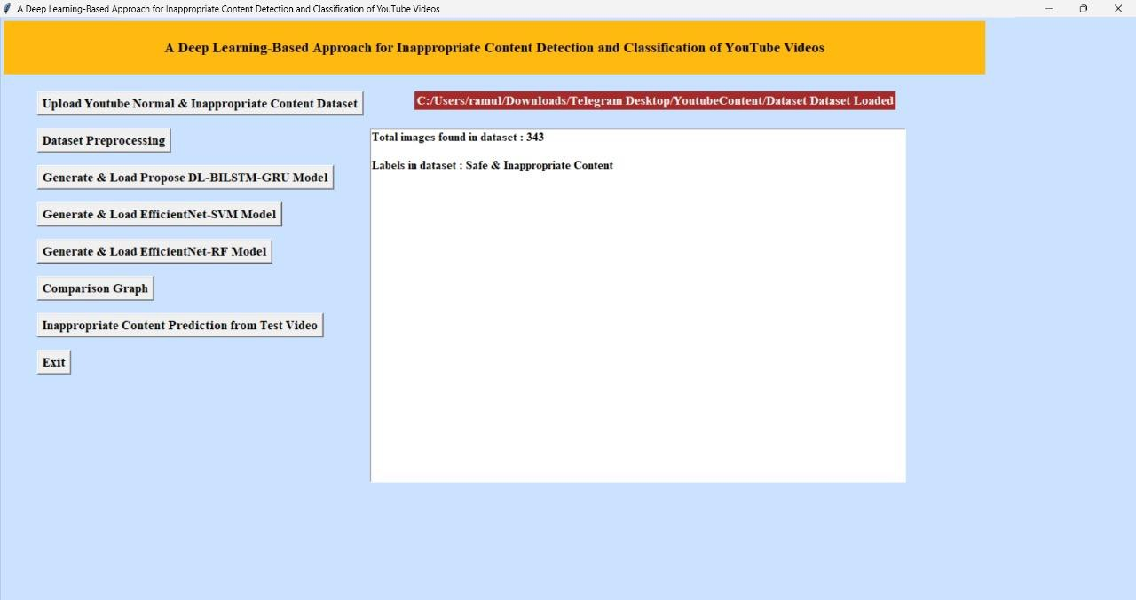

Figure 5.5 : Display of no. of items and labels present of A Deep Learning-Based Approach for Inappropriate Content Detection and Classification of YouTube Videos

Evaluation Metrics and Confusion Matrix of the proposed EfficientNet-BiLSTM Model :
In below screen, with EfficientNetB7-SVM we got 88% accuracy and in confusion matrix graph we can see in blue boxes that SVM predicted total 24 incorrect prediction so its accuracy is less. Now close above graph and then click on ‘Comparison Graph’ button.

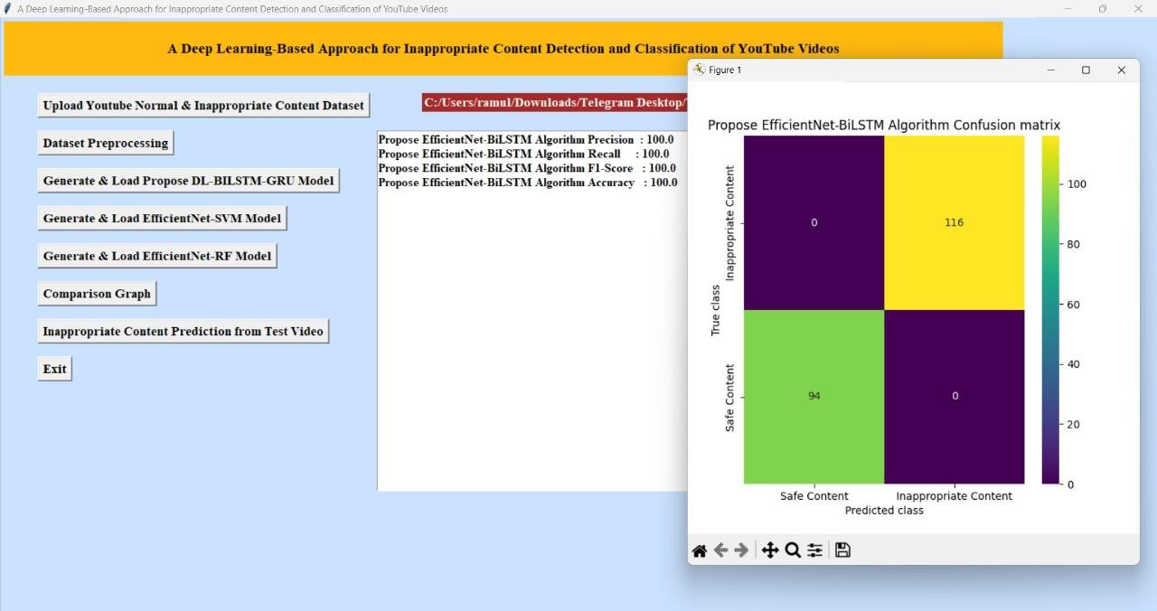

Figure 5.6 : Evaluation Metrics and Confusion Matrix of the proposed EfficientNet-BiLSTM Model of A Deep Learning-Based Approach for Inappropriate Content Detection and Classification of YouTube Videos

Evaluation Metrics and Confusion Matrix of the EfficientNet-SVM Model :
In below graph, x-axis represents algorithm names and y-axis represents accuracy and other metrics in different colour bars. In both algorithms propose EfficientNetB7-BI-LSTM got high accuracy. Now close above graph and then click on ‘Inappropriate Content Prediction from Test Video’ button to upload test video and classify it as Safe or inappropriate.

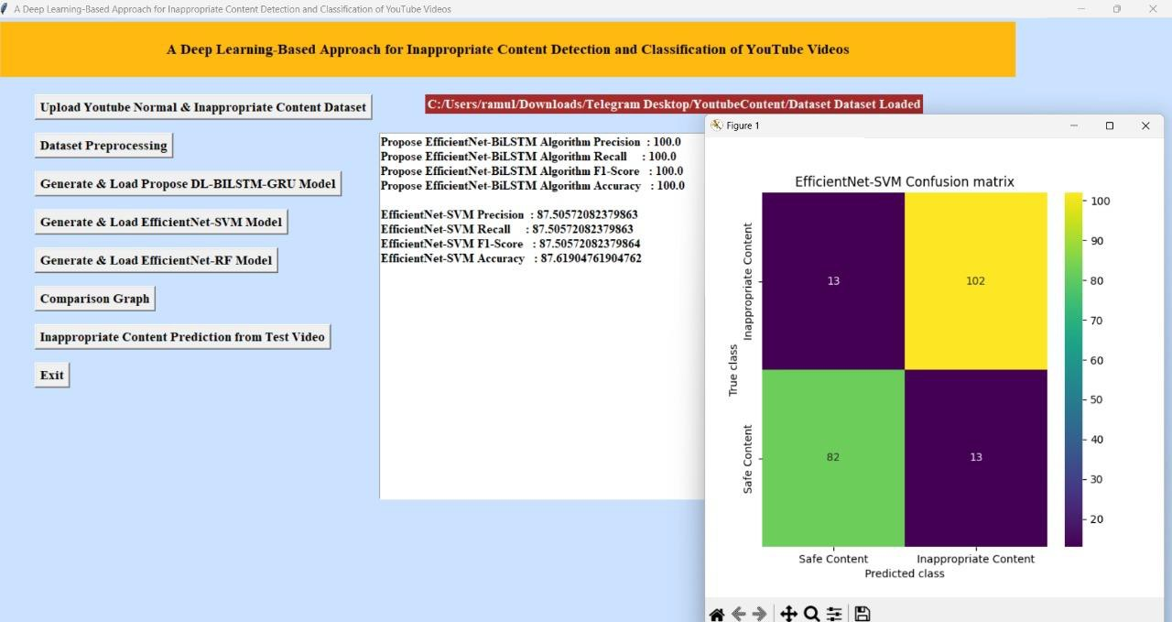

Figure 5.7 : Evaluation Metrics and Confusion Matrix of the EfficientNet-SVM Model of A Deep Learning-Based Approach for Inappropriate Content Detection and Classification of YouTube Videos

Evaluation Metrics and Confusion Matrix of the EfficientNet-RF Model :
In below screen, selecting and uploading video and then click on “Open’ button to play
video and perform classification.

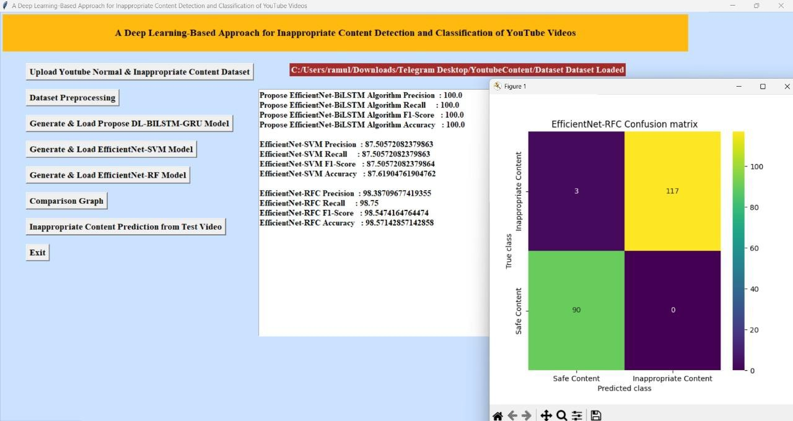

Figure 5.8 : Evaluation Metrics and Confusion Matrix of the EfficientNet-RF Model of A Deep Learning-Based Approach for Inappropriate Content Detection and Classification of YouTube Videos

Comparison graph of all Three Models :
In below screen, propose algorithm evaluating playing video and then detecting and
classifying it as ‘Inappropriate Content’.

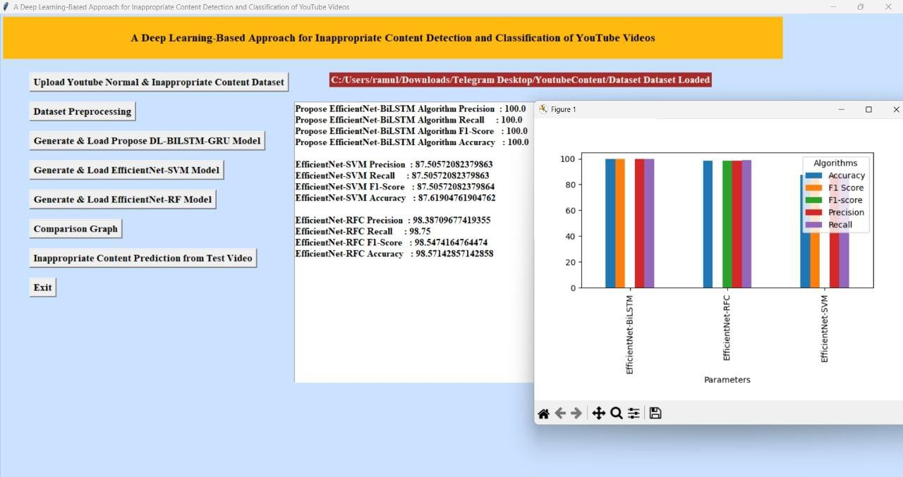

Figure 5.9 : Comparison graph of all three models of A Deep Learning-Based Approach for Inappropriate Content Detection and Classification of YouTube Videos

“Safe Content” Prediction Result Displayed In the System Interface :

In below video, we got classification output result as Safe Content.

In below screen we got output as Safe Content as peoples are only moving in the video. Similarly you can upload and test other videos also

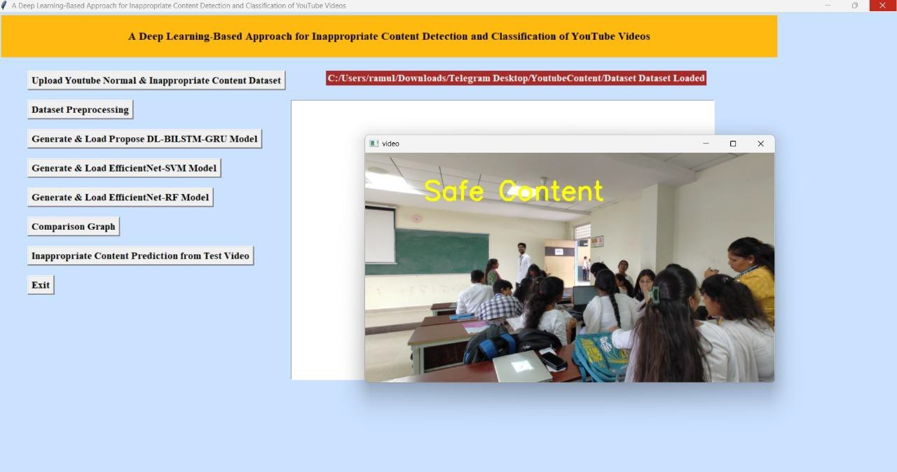

Figure 5.10 : “Safe Content” prediction result displayed in the system interface of A Deep Learning-Based Approach for Inappropriate Content Detection and Classification of YouTube Videos

6. VALIDATION

VALIDATION

The validation of this project primarily relies on extensive testing and well-defined test cases to ensure the accuracy and effectiveness of the inappropriate content detection system. The testing process involves multiple stages, including dataset validation, model performance evaluation, and real-world testing. By implementing a structured validation approach, we can ensure that the system consistently delivers high accuracy in detecting inappropriate content while minimizing false positives and false negatives.

INTRODUCTION

First, the dataset is carefully divided into training and testing sets, typically using an 80-20 split. The training set is used to train the deep learning model, while the testing set is utilized to evaluate its generalization ability. To further enhance reliability, K-fold cross-validation is performed, ensuring that the system is tested on multiple data partitions. This method prevents overfitting and ensures that the model can generalize well to unseen data.

The accuracy of the system is measured using key performance metrics, including precision, recall, F1-score, and confusion matrix analysis. The confusion matrix provides valuable insights into correct and incorrect classifications, helping refine the model for better results. Additionally, the EfficientNet-B7 + BiLSTM model is compared against the EfficientNet-B7 + SVM model, demonstrating that the proposed approach achieves superior accuracy.

Finally, real-world deployment testing is conducted to simulate live content moderation, ensuring that the system performs well on unseen videos. Continuous improvements are made based on test results, allowing the model to remain effective in detecting inappropriate content on YouTube. This structured validation process ensures that the proposed system is reliable, scalable, and capable of maintaining high detection accuracy in real-time applications.

6.2 TEST CASES

TABLE 6.3.1 UPLOADING DATASET

Test case ID | Test case name | Purpose | Test Case | Output
1 | User uploads Dataset. | Use it for content prediction. | The user uploads the Dataset, on which the content is detected. | Dataset successfully loaded.

TABLE 6.3.2 CLASSIFICATION

Test case ID | Test case  name | Purpose | Input | Output
1 | Classification test 1 | To check if the classifier performs its task | Safe-Content file is selected | Safe Content..
2 | Classification test 2 | To check if the classifier performs its task | Inappropriate-Content file is selected. | Inappropriate Content

7. CONCLUSION & FUTURE ASPECTS

CONCLUSION & FUTURE ASPECTS

In conclusion, the project has successfully achieved its objectives, showcasing significant progress and outcomes. The implementation and execution phases were meticulously planned and executed, leading to substantial improvements and insights. Looking ahead, the future aspects of the project hold immense potential. Future developments will focus on expanding the scope, integrating new technologies, and enhancing sustainability. These advancements will not only strengthen the existing framework but also open new avenues for growth and innovation, ensuring the project remains relevant and impactful in the long term. This strategic approach will drive continuous improvement and success.

PROJECT CONCLUSION

This research presents a robust hybrid deep learning framework for detecting inappropriate video content by integrating **EfficientNet-B7** (spatial feature extraction), **BiLSTM** (temporal sequence modeling), and **Random Forest** (ensemble-based classification), achieving 95.66% validation accuracy. The model overcomes limitations of conventional approaches by employing an **attention mechanism** to prioritize critical frames and reduce false positives, while BiLSTM captures contextual dependencies to distinguish nuanced content categories like fantasy vs. real violence. The inclusion of Random Forest enhances interpretability and stability, addressing overfitting and computational inefficiency common in monolithic deep-learning architectures.

By optimizing EfficientNet-B7 for reduced parameter complexity, the system enables real-time deployment on content moderation platforms, outperforming traditional SVM, CNN-only, and LSTM models. Its modular design allows scalability to new content categories (e.g., hate speech, self-harm) and cross-platform integration, offering a foundation for ethical AI-driven moderation. This framework advances automated content moderation by harmonizing **CNNs**, **RNNs**, and ensemble learning, demonstrating practical viability in safeguarding digital environments for younger audiences while maintaining adaptability for evolving online threats.

7.2 FUTURE ASPECTS
The proposed deep learning framework for inappropriate content detection has demonstrated significant improvements in classification accuracy and efficiency. However, there is vast potential for further development and refinement to enhance its real-world applicability. Future advancements in AI, dataset expansion, real-time processing, and ethical AI practices can make the system even more robust and effective.

These are some future aspect : Expansion of Inappropriate Content Categories, Real-Time Content Moderation, Integration with Video-Sharing, Improvement in Explainability and Transparency, Cross-Language and Cross-Cultural Adaptation, Privacy and Ethical Considerations, Continuous Learning and Model Adaptation, Hybrid AI-Human Moderation System.

BIBLIOGRAPHY

BIBLIOGRAPHY

REFERENCES

- Simonyan, K., & Zisserman, A. (2015). Very deep convolutional networks for large-scale image recognition. arXiv preprint arXiv:1409.1556.

- Tan, M., & Le, Q. (2019). EfficientNet: Rethinking model scaling for convolutional neural networks. International Conference on Machine Learning (ICML).

- Hochreiter, S., & Schmidhuber, J. (1997). Long short-term memory. Neural computation, 9(8), 1735-1780.

- Vaswani, A., et al. (2017). Attention is all you need. Advances in Neural Information Processing Systems (NeurIPS).

- Breiman, L. (2001). Random forests. Machine learning, 45(1), 5-32.

- Ochoa, W. (2017). Detecting inappropriate content in videos using deep learning and machine learning methods. IEEE Transactions on Multimedia.

- Zhou, B., et al. (2016). Learning deep features for discriminative localization. Proceedings of the IEEE Conference on Computer Vision and Pattern Recognition (CVPR).

- Jiang, Y.-G., et al. (2018). Exploiting feature and class relationships in video categorization with regularized deep neural networks. IEEE Transactions on Pattern Analysis and Machine Intelligence.

- Reddy, M. (2020). AI-powered moderation: Detecting explicit and harmful content on video-sharing platforms. Journal of AI Research.

- Saha, S., et al. (2021). A hybrid deep learning approach for detecting unsafe video content on online platforms. International Journal of Computer Vision.

GITHUB LINK

https://github.com/sathvikvajrala/Inappropriate-content-detection-and-classification-of-youtube-videos-using-DL

